Properties of synchrotron light for the TESLA spectrometer magnets

N.A.Morozov
Laboratory of Nuclear Problems, JINR, Dubna, May 2003
(internal report)

In this report some calculations for the providing the useful dependencies for the synchrotron radiation in the TESLA spectrometer magnets (basically in the spectrometer one) are presented for its beam energy region. They’ll be useful for the spectrometer design and may be for the design of the SR detectors.

1.Electron energy loss due to SR

The calculations were done for the spectrometer magnet with the length 3 m and bending angle 1 mrad and for the ancillary magnet with the length 1.5 m and angle 0.5 mrad. The results are presented in the Fig.1 for the working range of the magnets. In the Fig.2 the power loss curves due to the SR in the magnets are presented. It was assumed that the average electron beam current is equal 45 μA for the E=250 GeV, and 30 μA for the E=400 GeV.
Fig.1. Energy loss due to synchrotron radiation in the TESLA spectrometer magnets
Fig.2. Power loss due to synchrotron radiation in the TESLA spectrometer magnets

2.Divergence angle for the SR

The calculation result (divergence angle = 1/γ) is presented in the Fig.3.
Fig.3. Synchrotron radiation divergence angle

3.Critical SR wave length and energy

For calculation of this SR characteristic we have used the curvature radius of electron orbit R=3000 m [R(m)=E(GeV)/(0.3B(T))]. The results are presented in the Fig.4 – 5.
Fig.4. Critical SR energy for the spectrometer magnet
Fig.5. Critical SR wave length for the spectrometer magnet

4. Total beam displacement in the spectrometer

The present spectrometer setup (spectrometer magnet length is 3 m, ancillary magnet one is 1.5 m) is presented in the Fig.6. The distance between magnets (from pole to pole) is equal to L_{as}=10 m. The total beam displacement is equal to
X_{tot} = X_{a} + X_{as} + X_{s} ≅ 5.8 mm,
where X_{a} = X_{s} = R_{c} α²/2 ≅ 0.4 mm (for R_{c}=3000 m, α=0.5 mrad);
X_{as} = α L_{as} = 5 mm.
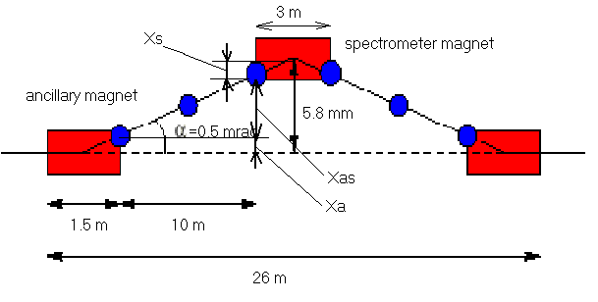

Fig.6. TESLA magnetic spectrometer setup

5. Number of photons radiated by one electron and spectrometer energy resolution

Number of photons radiated by one electron versus the beam energy is in the Fig.7, and the fluctuation of average electron energy at SR is in the Fig.8. This fluctuation gives the restriction on the energy resolution for the spectrometer.

Fig.7. Number of photons radiated by one electron (in average)
Fig.8. Fluctuation (relative) of the average electron energy due to SR

6. SR spectrum

The results of calculation of the spectrum (for both planes of polarization) emitted by spectrometer magnet at 45, 250 GeV (I_{beam}=30 μA) and 400 GeV (I_{beam}=45 μA) beam energy are plotted in the Fig.9.

Fig.9. Differential number of photons produced by an electron beam

The photons radiated from the spectrometer magnet hit the vacuum chamber under a small angle 1 mrad. If to assume that the incident photons get deflected via Compton scattering and this process determines the angle, under which the photons pass the vacuum chamber wall, the average angle of photons chamber wall penetration is φ_{penetr.}=63 º. Therefore the mean distance d the photon travel inside the vacuum chamber is given by:
d = 2.2 X_{o}
where X_{o} is the wall thickness.
The transmission factor for the stainless chamber wall thickness 1.5 and 2 mm as a function of the photon energy is presented in the Fig.10. The spectrums of the photons after the vacuum pipe wall passing are presented in the Fig.11 and 12.

Fig.10. The photons transmission of the vacuum pipe with wall thickness 1.5 and 2 mm
Fig.11. The photons spectrums after the vacuum pipe 1.5 mm wall passing
Fig.12. The photons spectrums after the vacuum pipe 2 mm wall passing

7. SR detection channel

The number of the SR measurement channel calculated by:
N_{channel} = L _{s-d} /(γ d _{ch})
where L _{s-d} the distance between detector and spectrometer, d _{ch} the size of one channel (= 30 μ m). The results of calculation for L _{s-d} = 25 and 200 m are presented in the Fig.13.

Fig.13. Number of SR measurement channel

