Magnetic field calculations for the TESLA spectrometer ancillary magnet (in the version of ½ of the main one) by the MAFIA code

N.A.Morozov
Laboratory of Nuclear Problems, JINR, Dubna, July 2003
(internal report)

Preliminary magnetic field calculations have been provided for the TESLA ancillary and main magnets by 2D computer program POISSON SUPERFISH. Those calculations gave the principal decision for the magnets design and their manufacturing tolerances. For the more detailed magnets design the magnetic field1 calculations were started by 3D electromagnetic simulation code. At the first step the RADIA code [2] was used. The calculations by this code have been shown that the magnetic field results are strongly depending from the type of the magnet geometry mesh and there are the problems with the solution convergence. At the second step the calculations by the 3D MAFIA code [1] were realized.
We initialized our work with MAFIA computations for the ancillary magnet as it is in two times shorter of the main one (this requires the less ammounts of the mesh elements). The cross-section of the ancillary magnet was used fully similar to the main magnet one (version1). For the static magnetic field calculations three MAFIA blocks were used:
- M – the mesh generator.
- S – the static solver.
- P – the post processor.

Mesh generator

The mesh generation for the ancillary magnet 3D model was realized with 50000 to 200000 meshpoints. Because of the magnet symmetry it was generated for the ¼ magnet part. The minimal value for the meshsize for this model was achieved about 1 – 2 cm. The exitation coils in the MAFIA code are defining by the filaments. The magnet coil was simulated by 12 filaments (2 vertical layers × 6 filaments). The filaments have the rectangular shape in the plane view. Some 3D and 2D views of the model are presented in the Fig.1 – 3.

Solver

For the magnet solver simulation it was used the same iron magnetization table as in case of 2D POISSON SUPERFISH code. The required maximal magnet gap field was achieved for the same current of the coil exitation as in 2D simulation.
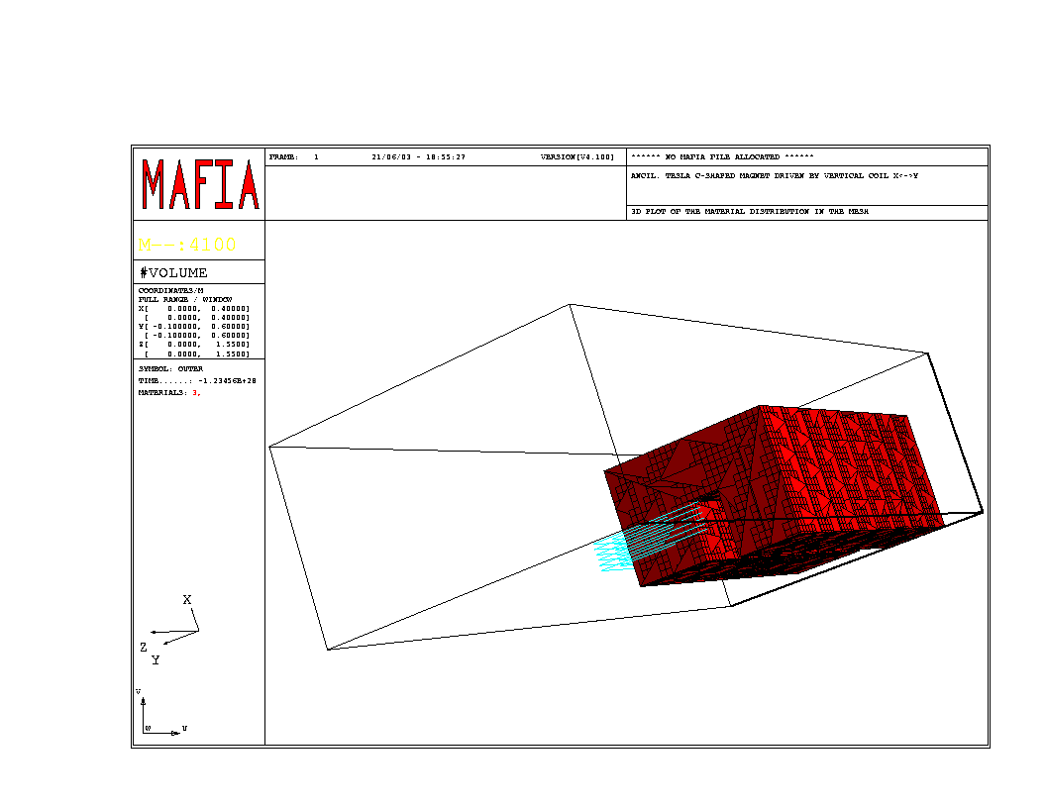
Fig.1. 3D view of the ancillary magnet model with iron yoke and filaments which represent the coil
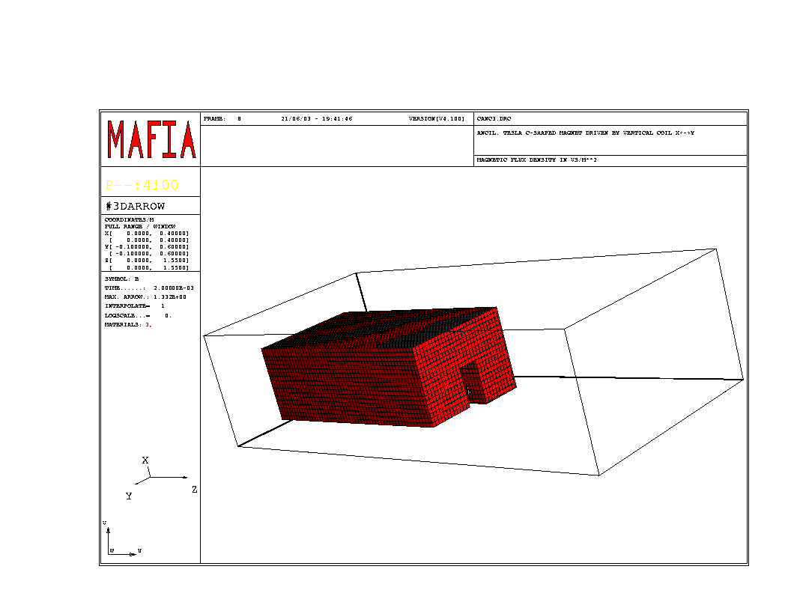
Fig.2. 3D view of the magnet model for the iron only

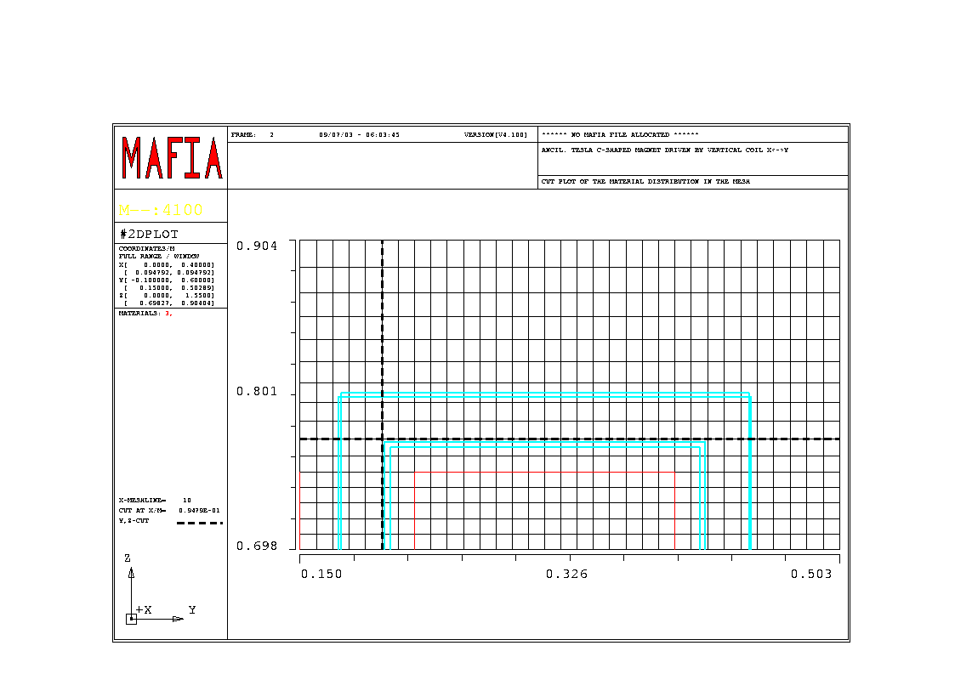
Fig.3. 2D view of the magnet model with the grid in the median magnet plane showing the end part of the pole and the filaments

Post processor

Some post processor views presenting the overall impression from the 3D picture for the ancillary magnet field are shown in the Fig.4 – 12 (maximal magnetic field B_{gap}=0.44 T).
Some quantity results of the 3D magnetic field simulations are presented in the Fig.13 – 15. The results of calculation for the magnetic field integral do not depend from the number of the meshpoints from the number of 80000. The meshpoints number 200000 are enough for the accurate splining of the magnetic field curve.
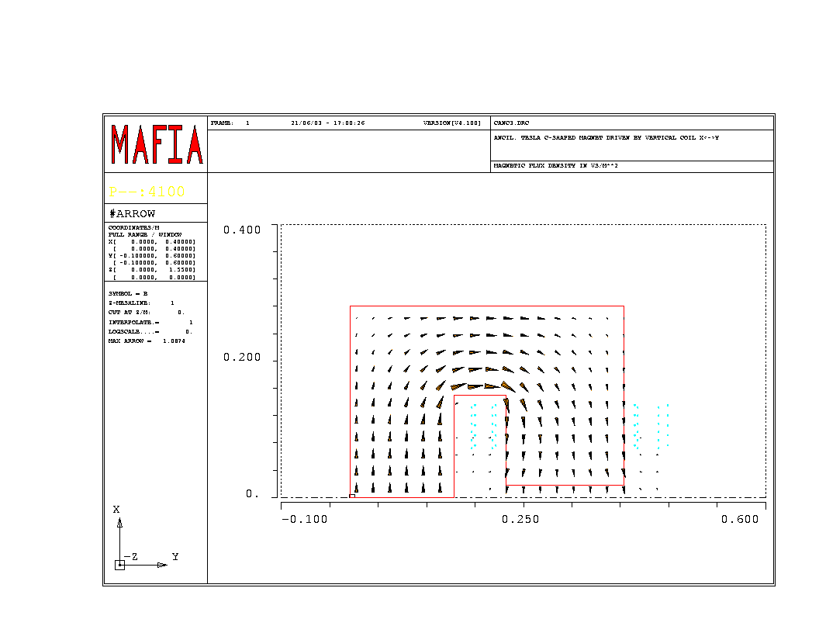
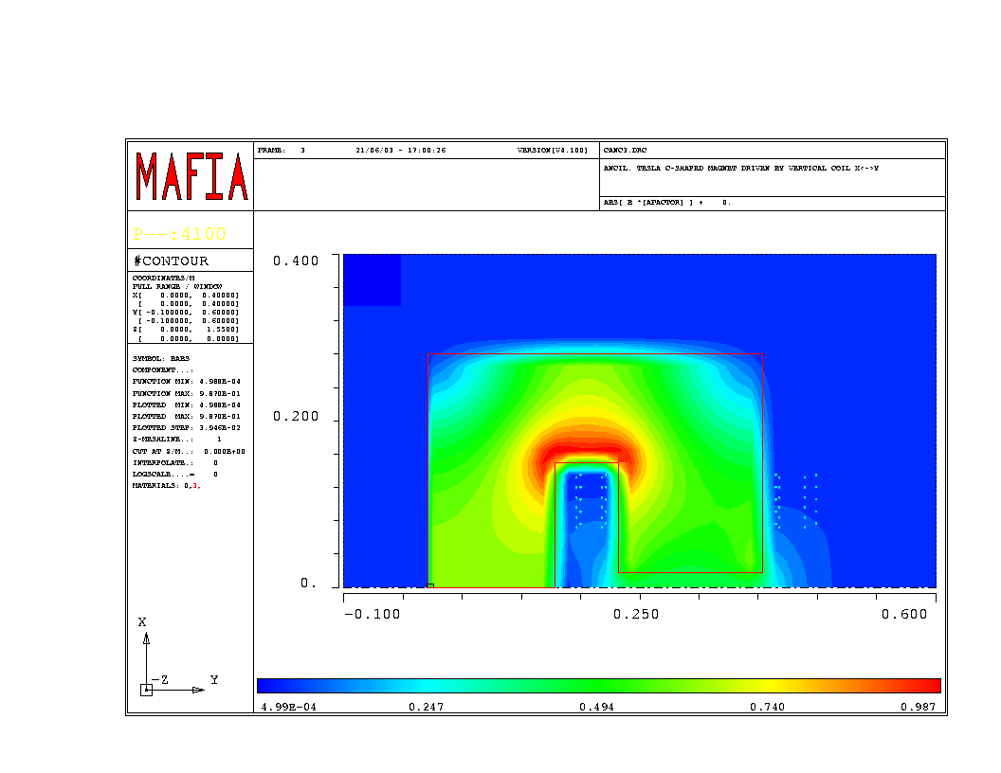
Fig.4. Flux density in the symmetry plane of the iron yoke

Fig.5. Magnetic field contour plot (middle cross-section, Z=0)

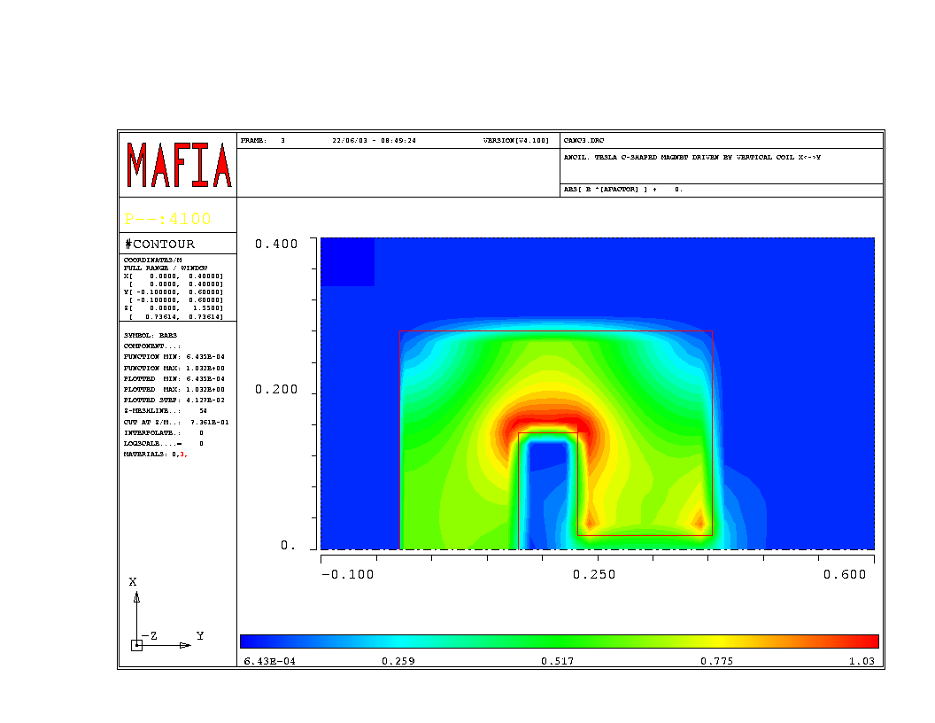
Fig.6. Magnetic field contour plot (cross-section near the pole edge, Z=52 cm)
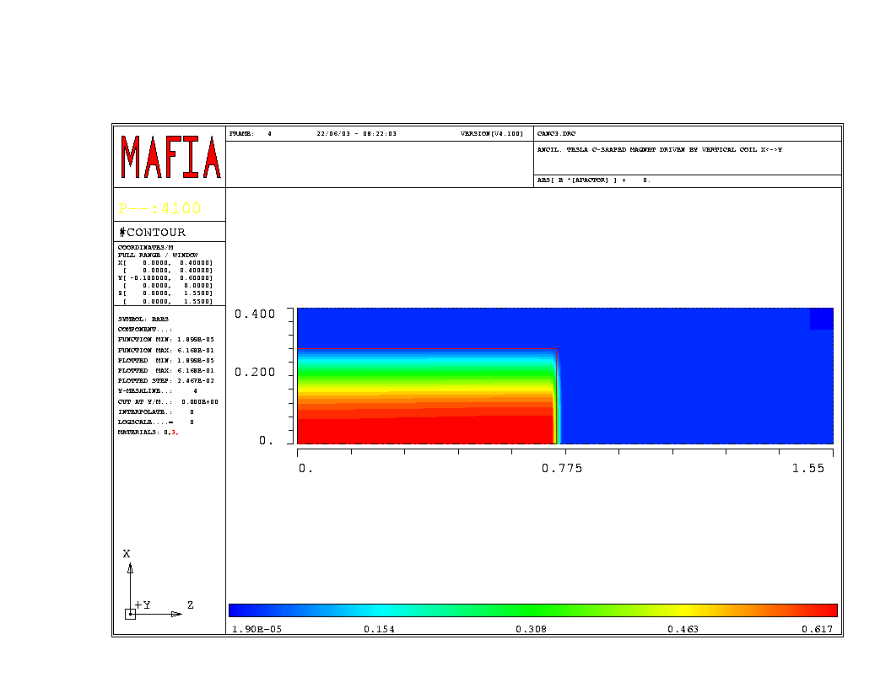
Fig.7. Magnetic field contour plot (vertical cross-section throw the middle point of the vertical yoke, X=8 cm)
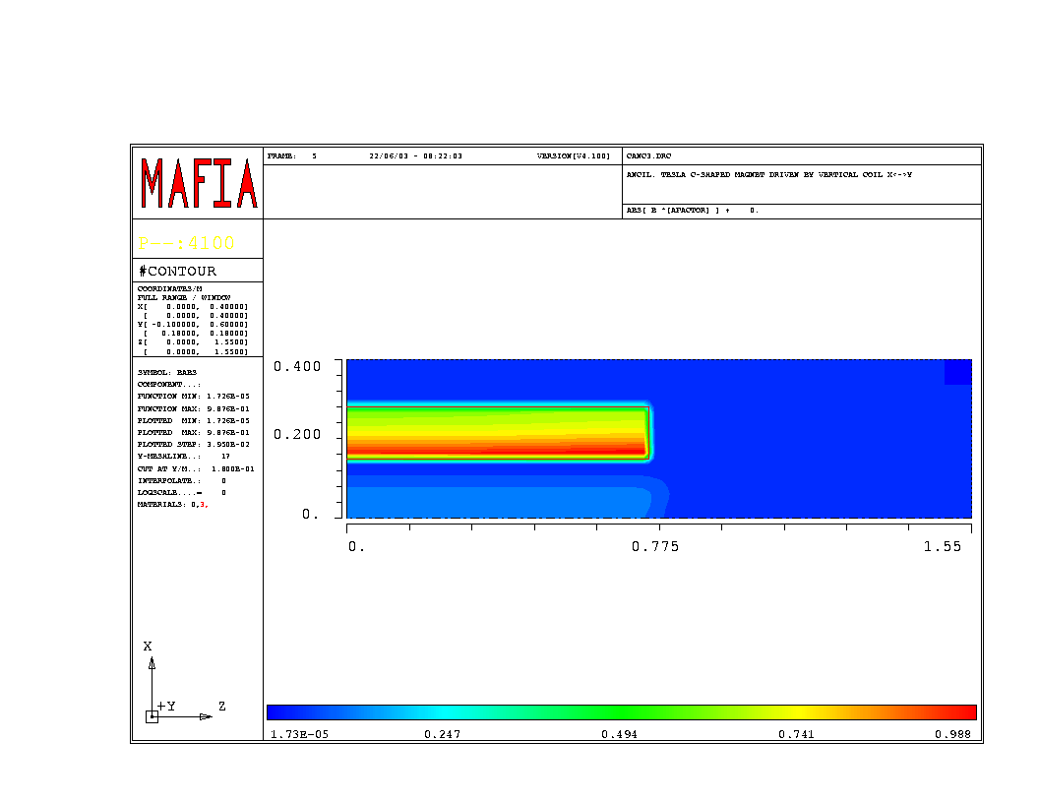
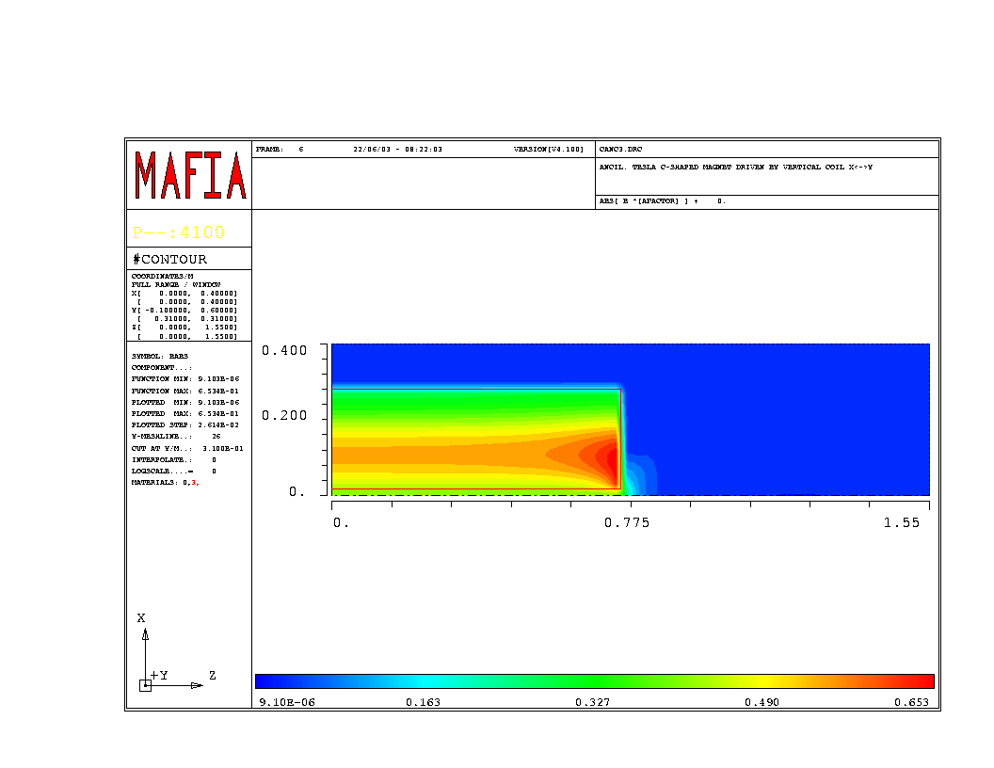
Fig.9. Magnetic field contour plot (vertical cross-section throw the middle point of the horizontal yoke, X=20 cm)

Fig.10. Magnetic field contour plot (vertical cross-section throw the middle point of the pole, X=31 cm)
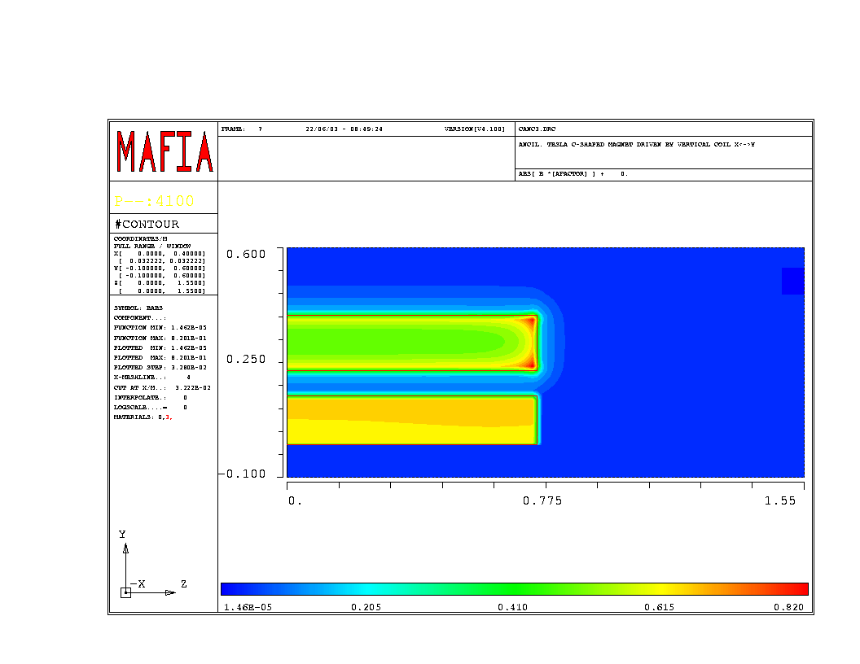
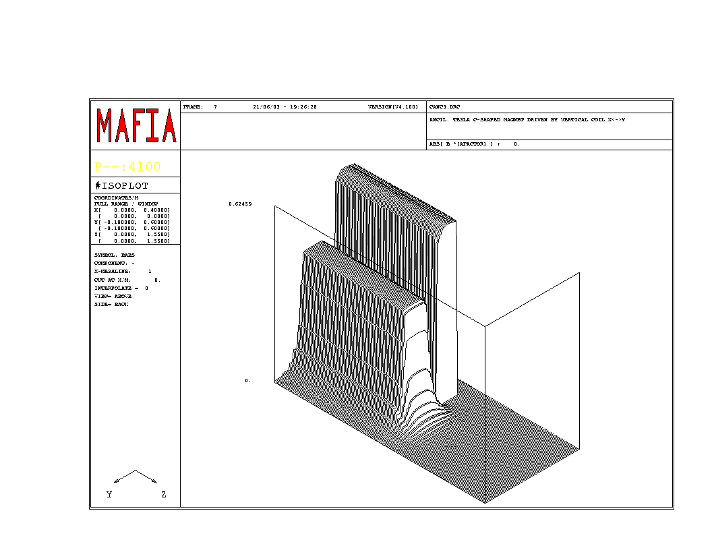
Fig.11. Magnetic field contour plot (horizontal cross-section, Y=2.5 cm)

Fig.12. Isoplot view of the magnetic field in the median magnet plane

Fig.13. Normalized magnetic field in the middle cross-section of the ancillary magnet

Fig.14. Normalized magnetic field along the beam line
Fig.15. Longitudinal magnetic field integral (normalized)

Conclusions

- The ancillary magnet (V.1) field simulation by 3D MAFIA code model was realized.
- In the magnet middle cross-section the field uniformity region is closed to 2D simulation results.
3. Because of the 3D effects the uniformity region for the longitudinal magnetic field integral is shifted on about 15 mm and decreased to 10 mm. This effect has to be taken into account in the magnet design.

References

[1] T.Weiland et al., http//www.cst.de/.
[2] Chavanne J., Chubar O., Elleaume P. - RADIA, a 3D Magnetostatic Computer Code. IMMW-12, ESRF, Grenoble, France, 2001.

