Calculations on optimization of the parameters for the TESLA spectrometer magnet

N.A.Morozov
Laboratory of Nuclear Problems, JINR, Dubna, January 2003
(internal report)

The results of the preliminary estimation of the parameters for the TESLA spectrometer magnet is reported in [1]. In this next internal report the results of calculations on optimization of it’s geometry are reflected. For the magnet optimization the 2D POISSON model 1 [1] was used. The aim of optimization was the increasing of the transverse magnet aperture with the normalized magnetic field uniformity in the limits ±1.×10 ^{–5}. In the Fig.1 the normalized magnetic field distributions are presented for the preliminary magnet geometry. During the optimization procedure the transverse magnet aperture for the maximal magnetic field - (ΔX_{un. 400}), for the minimal one - (ΔX_{un. 90}) and common - (ΔX_{un. com.}) were calculated. The view of the model with the magnet sizes marked for using in optimization procedure is presented in the Fig.2.
Fig.1. Normalized magnetic field of the spectrometer magnet (preliminary geometry).

In this procedure the next magnet sizes (Fig.2) were changed:
- H_{m} – magnet height;
- S_{m} – magnet vertical yoke width;
- H_{c} – magnet pole and vertical yoke height;
- S_{p} – magnet pole width;
- S_{sh} – magnet pole shim width (the shim height – 1 mm).

Fig.2. The view of the model 1 (the sizes for optimization are marked).

The results of calculations of the H_{m,} S_{m,} H_{c} and S_{p} influence on the magnetic field uniformity are presented accordingly in the Fig.3, 4, 5, 6. From those figures it is possible to notice the most powerful influence of the H_{c} parameter. In the Fig.7 the normalized magnetic field distributions are presented as optimized by means of H_{c.}
Fig.3. The uniformity regions dependence from the magnet height.
Fig.4. The uniformity regions dependence from the magnet vertical yoke width.

Fig.5. The uniformity regions dependence from the magnet pole and vertical yoke height.
Fig.6. The uniformity regions dependence from the magnet pole width.
Fig.7. Normalized magnetic field of the spectrometer magnet (optimized by means of H_{c}).

It is well known from the dipole magnet technique that the using of the pole shims is rather effective in increasing the magnet aperture when the required magnetic field uniformity is in the range ±1.×10 ^{–4} or more. The effect of such shims was studied for the spectrometer magnet with the field uniformity ±1.×10 ^{–5}. In the model 1 such shims were inserted from one side of the magnet poles. Their height was 1 mm and the width S_{sh} was varying. The results of calculations of the S_{sh} influence on the magnetic field uniformity are presented in the Fig.8. The calculations show that for the field uniformity ±1.×10 ^{–5} the pole shims are useless because of the magnet saturation effects. In the Fig.9 it is possible to see, that when the magnetic field uniformity for the maximal field level is optimal (S_{sh} =45 mm), for the minimal field the uniformity is far from optimal.

Fig.8. The uniformity regions dependence from the magnet pole shims width.

The optimized geometry (cross section) of the TESLA spectrometer magnet is presented in the Fig.10. The 3D view of this magnet is presented in the Fig.11 (the coils front parts are removed).The normalized magnetic field for the final magnet geometry is presented in the Fig.12. The parameters of optimized spectrometer magnet are collected in the Tab.1.
Fig.9. Normalized magnetic field of the spectrometer magnet (S_{sh} =45 mm).
Fig.10. The cross-sectional view of the optimized geometry of the TESLA spectrometer magnet.
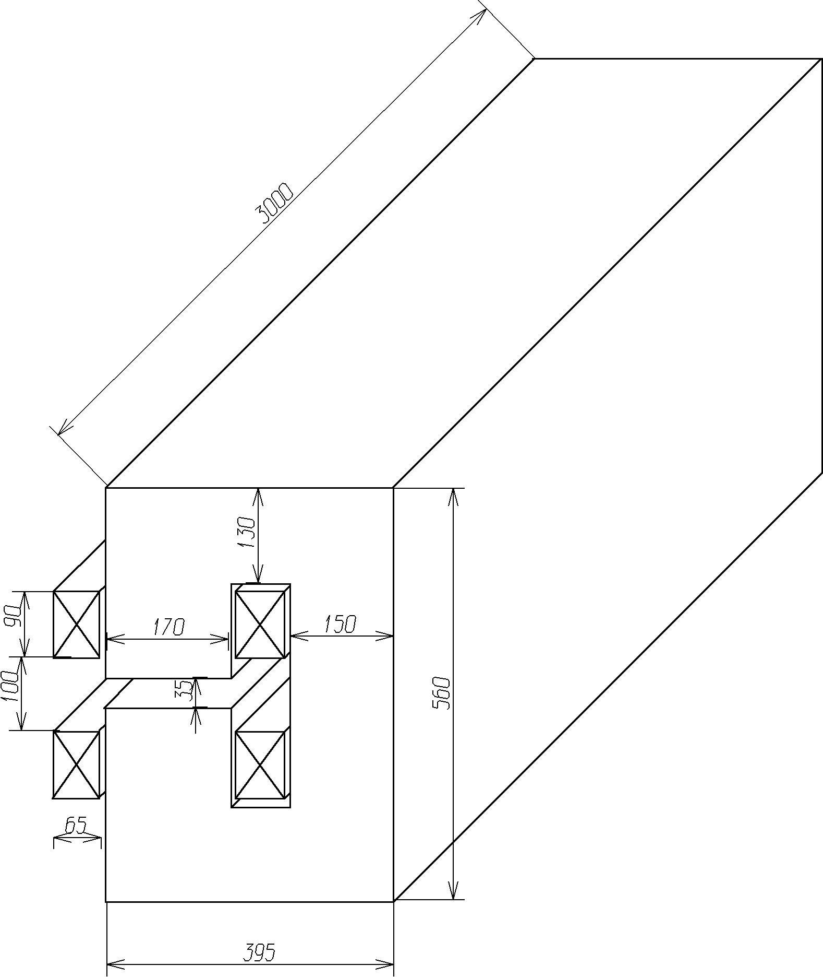
Fig.11. The 3D view of the spectrometer magnet (the sizes are in mm).

Fig.12. Normalized magnetic field of the spectrometer magnet (optimized geometry).
Table 1. The main technical parameters of the TESLA spectrometer magnet (optimized geometry).

Magnetic field (min/max) (Т) | 0.1/0.44
Pole gap (mm) | 35
Yoke type | C
Yoke sizes (mm) | 395×560×3000
Yoke weight (t) | 4.51
А*turns (1 coil) (max) | 6335
Turns number (1 coil) | 6*4=24
Conductor type | Сu, 12.5×12.5, ∅7.5
Coils current (max) (А) | 264
Current density (max) (A/mm ²) | 2.4
Coils voltage (max) (V) | 13.3
Coils power dissipation (max) (kW) | 3.5
Number of water cooling loops | 12
The length of one cooling loop (m) | 28
Water input pressure (Bar) | 4
Water input temperature (deg C) | 20
Temperature rise (deg C) | 0.55

Conclusions

With the purpose of increase of the horizontal aperture of the spectrometer magnet the calculations on optimization of its yoke shape were carried out. The modified geometry of the magnet was determined, allowed to increase the horizontal aperture in the working range of magnetic fields up to 19 mm (relative uniformity of the magnetic field - ±1.×10 ^{–5}).

References

[1] N.A.Morozov. The preliminary estimation of the parameters for the TESLA spectrometer magnet. LNP, JINR, Dubna, December 2002, (internal report).

