The preliminary estimation of the parameters for the TESLA spectrometer magnet

N.A.Morozov
Laboratory of Nuclear Problems, JINR, Dubna, December 2002
(internal report)

The preliminary estimation of parameters of the TESLA spectrometer has been carried out on the basis of the principal circuit (Fig. 1) presented in TESLA TDR [1]. As prototypes magnets the magnets of spectrometer SLC [2] and LEP [3] have been considered. Their basic parameters are collected in the Tab. 1.
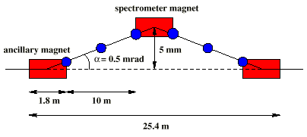

Fig.1. TESLA magnetic spectrometer.

Table 1. The main spectrometers magnet parameters.

 | SLC [2, 4, 5] | LEP [3, 6, 7, 8] | TESLA (Proposal)
Energy – E (GeV) | 42 - 50 | 40 - 100 | 90 - 400
Absolute accuracy of energy measurement-ΔE/E | 5×10 ⁻⁴ | 1×10 ⁻⁴ | 1×10 ^{–4} - 1×10 ^{–5}
Deflection angle (mrad) | 18.286 | 3.75 | 1
Magnetic field range (T) | 0.88 – 1.1 | 0.086 – 0.216 | 0.1 – 0.44
Magnetic field integral (T•m) | 2.56 – 3.05 | 0.5 – 1.242 | 0.3 – 1.33
Magnetic measurement error of the field integral (relative) | 7×10 ⁻⁵ | 3×10 ⁻⁵ | 1×10 ⁻⁴ - 1×10 ⁻⁵
Magnet iron length (m) | 2.5 | 5.75 | 3
Effective magnet length (m) |  |  | 3.045
Gap height (mm) | 31.7 | 100 | 35
Magnet type | H | C | C
Laboratory ∫B•dl measurement technique | Mowing wire, mowing probe (NMR, Hall) | Mowing probe (NMR, Hall), search coil | Should be estimated
Operational ∫B•dl measurement technique | Flip coil, fixed probes (NMR) | Fixed probes (NMR) | Should be estimated
Energy loss due synchrotron radiation (max) (MeV) |  | 3.55 | 120

- The estimation of the magnet parameters.

The basic specification for the choice of parameters of the TESLA spectrometer magnet are - the deflection angle and the energy working range (Tab.1). Using the formula for the small deflection angle (θ) in the bending magnet (∫B•dl = B•L_{mag}) for the relativistic particles with the energy E:

θ (mrad) = 299.792 B (T) •L_{mag} (m) / E (GeV) (1)

it is possible to produce the set of curves B = f(L_{mag}). This set is presented in the Fig.2 for three deflection angles θ = 1, 0.6 and 0.2 mrad and for two electron energies E = 90 and 400 GeV. In this Fig. the working ranges for SLC and LEP spectrometer magnets and the field ranges for the METROLAB NMR Teslameter probes [9] are presented too. Because of high electrons energy for the TESLA spectrometer magnet the energy loss due the emitting the synchrotron light is essential. The calculation of this energy loss were done by means of formula:

ΔE_{SR} (MeV) = 1.265382×10 ^{–3} L_{mag} (m) • B (T)² • E (GeV)² (2).

The results of calculation by means of formula (2) for three deflection angles and maximal electrons energy are presented in the Fig.3.

Fig.2. The B=f(L_{mag}) dependences for the TESLA spectrometer magnet.
Fig.3. The energy loss due synchrotron radiation in the TESLA spectrometer magnet for the electrons energy 400 GeV.

For the magnet length estimation it is required to take into account the next conditions.
The increase in length of the magnet:
- reduces a required maximum level of the magnetic field in pole gap (the magnet coils power dissipation is reduced, the realization of the yoke temperature stability is easy),
- reduces the magnet field working range (the influence of nonlinear effects in the structure of the field goes down),
- reduces the synchrotron radiation power loss (the realization of the yoke temperature stability is easy) ,
- reduces the fraction of the fringe magnetic field integral in the general field integral (accuracy of measurement of the field integral increases) ,
- reduces the accuracy of the magnet manufacturing,
- increases the difficulties on manufacturing and manipulation the device for the magnetic field measurement.

Except for that it is necessary to take into account the possible future increase in the maximal working energy of the TESLA accelerator up to 800 GeV. The account of all these circumstances has allowed to stop on the length of the magnet - 3 m. To that length corresponds the working range of the magnetic field - 0.44 - 0.1 Т. This range may be measured by two types of METROLAB NMR probes (1062-2, 1062-3).
At the choice of the magnet yoke shape the preference has been given to С-type, as at the magnet length of 3 m the access into pole gap for installation and manipulation with vacuum chamber and magnetic field measurement equipment is essentially easy.
On the estimation of the pole gap it was taken into account the possibility of placement vacuum chamber ∅20 mm, NMR probe and traveling stage for moving wire technique for magnet calibration during energy measurements. This estimates the required pole gap – 35 mm. The principal drawing of this equipment placement is presented in the Fig.4. The axis of the vacuum chamber and magnet are shifted on 5 mm, thus the beam passes along the chamber axis if the spectrometer is switched off. If the spectrometer is switched on, the beam center is displaced on 5 mm from the chamber axis. The proposed TESLA spectrometer magnet parameters are included into the Tab.1.

Fig.4. Cross-sectional view of the spectrometer magnet pole gap.

- Magnetic field calculations.

The magnetic field calculations for the spectrometer magnet were done by means of 2D magnetostatic computer code POISSON SUPERFISH [10]. By help of this code two models were realized:
- Model 1 represented the middle section of the magnet in X-Y plane (Fig.5). This model was used for the magnetic field calculation in transverse (X) direction of the pole gap.
- Model 2 represented the longitudinal section of the magnet (throw the magnet pole axis) in Z-Y plane (Fig.5). The view of model 2 is presented in the Fig.7. The section of the pole was spread only to 200 mm in its depth. For short circuit of the magnetic flux the special yoke is entered into model 2 (gray color, Fig.7). This model was used for the fringe magnetic field calculation in longitudinal (Z) direction of the pole gap.

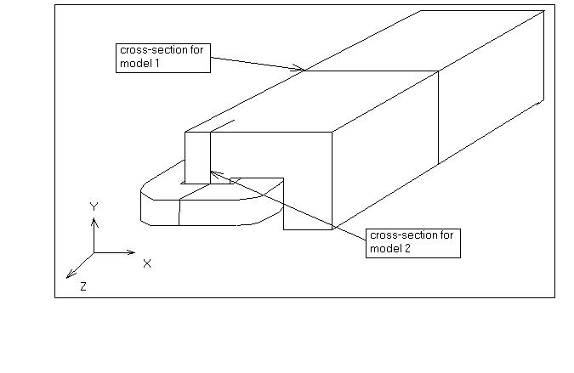
Fig.5. The 3D view of the spectrometer magnet (1/2 part). Cross-sections for 2D POISSON models are shown.
Fig.6. The view of the model 1.

In the Fig.8 the results of POISSON SUPERFISH calculation for model 1 are presented with view of magnetic field flux lines. The magnetization curve for the magnet is presented in the Fig.9 and in the Fig.10 – the relative difference between magnetization curves with and without (μ_{Fe}=∞) saturation effects. This calculation estimates the required A*turns range for spectrometer magnet – (1420 – 6335) (per one coil).
In the Fig.11 the magnetic field distributions in the X direction of the spectrometer magnet for the minimal and maximal electrons energy are presented, in the Fig.12 – the normalized ones. The relative magnetic field uniformity 10 ppm exists for the working range in the horizontal magnet aperture ±5.5 mm.

Fig.7. The view of the model 2.

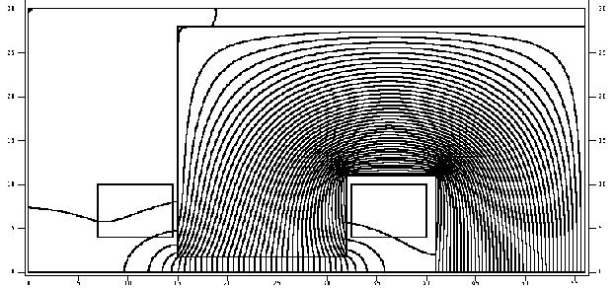

Fig.8. The view of the POISSON SUPERFISH model 1 showing magnetic flux lines.
Fig.9.Excitation curve for spectrometer magnet and with μ_{Fe}=∞.
Fig.10. The effect of saturation for spectrometer magnet.
Fig.11. Magnetic field distribution of the spectrometer magnet.
Fig.12. Normalized magnetic field of the spectrometer magnet.

Calculations carried out by means of model 1 have allowed to establish the final parameters of the magnet. At the choice the conductor type for the magnet coils and the maximal conductor current density it was possible to provide the growth of temperature of the coils within the limits of one degree. It will allow to reduce to the minimum the temperature effects of magnet coils and yoke for the spectrometer magnetic field. Parameters of the magnet are in the Tab. 2.

Table 2. The main technical parameters of the TESLA spectrometer magnet.

Magnetic field (min/max) (Т) | 0.1/0.44
Pole gap (mm) | 35
Yoke type | C
Yoke sizes (mm) | 410×560×3000
Yoke weight (t) | 4.9
А*turns (1 coil) (max) | 6355
Turns number (1 coil) | 4*5=20
Conductor type | Сu, 12.5×12.5, ∅7.5
Coils current (max) (А) | 318
Current density (max) (A/mm ²) | 2.8
Coils voltage (max) (V) | 13.3
Coils power dissipation (max) (kW) | 4.2
Number of water cooling loops | 8
The length of one cooling loop (m) | 35
Water input pressure (Bar) | 4
Water input temperature (deg C) | 20
Temperature rise (deg C) | 1.16

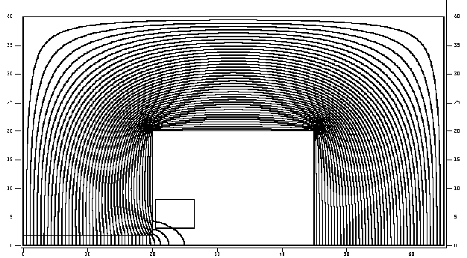 The POISSON model 2 was used for calculation of the fringe magnet field in longitudinal direction and the effective magnet length. In the Fig.13 this model is presented with the magnetic flux lines distribution. In the Fig.14 the magnetic field distributions in Z direction of the magnet are presented.
Fig.13. The view of the POISSON SUPERFISH model 2 showing magnetic flux lines.
Fig.14. Magnetic field distribution in Z direction of the spectrometer magnet.
Fig.15. The normalized effective length of the spectrometer magnet.

The change of the magnet effective length over the working range of the magnet is shown in the Fig.15.
Fig.16. The magnetic field gradient distribution in Z direction.

The calculations of the longitudinal magnetic field gave the possibility to determine the region of using the NMR probes during the measurements of the field. According to the technical specification for the METROLAB NMR probes [9] the probes 1062-2 and 3 work in the magnetic field with uniformity <1200 ppm/cm. In the Fig.16 the magnetic field gradient and the ultimate gradient line for NMR probes are presented. The crosses of associated lines estimate that the NMR probes have the working region up to 40 mm from the pole edge. This means that by help of NMR probes it’ll be possible to measure 96% of the whole magnetic field integral.

Conclusions

As the results of the magnetic field calculations for the spectrometer magnet it’s preliminary magnetic and technical parameters were estimated. This data will serve as the starting point for further optimization and preparation of it’s technical design.

References

[1] TESLA Technical Design Report. Part IV, p.143.
[2] J. Kent et al. Precision Measurements of the SLC Beam Energy.SLAC-PUB-4922, LBL-26977 , 1989.
[3] B. Dehning. Status of the LEP2 Spectrometer Project. In Proceedings of EPAC 2000 , Vienna, Austria, 2000.
[4] S.Watson et al. Precision Measurements of the SLC Reference Magnets. SLAC-PUB-4908, LBL-26956, 1989.
[5] M.Levi et al. Precision Measurements of the SLC Spectrometer Magnets. SLAC-PUB-4654, 1989.
[6] F.Roncarolo et al. High Accuracy Field Mappings with a Laser Monitored Travelling Mole. In Proceedings of EPAC 2000 , Vienna, Austria, 2000.
[7] J.Prochnow. The LEP Energy Spectrometer. Diplomarbeit in Physik, 2000.
[8] F.Roncarolo. High Accuracy Magnetic Field Mapping of the LEP Spectrometer Magnet The thesis work, Academic Year 1999-2000.
[9] METROLAB Instruments SA, PT 2025 NMR Teslameter, Probes type 1062. http://www.metrolab.com.
[10] J.H.Billen, L.M.Young. POISSON SUPPERFISH Documentation, LA-UR-96-1834.

