Some recollections of Franz Heymann, from Keith Potter, CERN Geneva

I first knew Franz in 1962 at UCL, when he was one of our lecturers on the undergraduate physics course and, luckily for me, also my third year laboratory tutor. It was typical of Franz that one day, when he was lunching with us in the students’ refectory, he got very enthusiastic about plans at the CERN laboratory in Geneva to collide two 26 GeV proton beams of sufficient intensity to obtain a useable number of collisions with 52 GeV in the centre of mass. I guess we had recently learnt some relativistic mechanics and at least, in theory, were able to calculate the centre of mass energy in a fixed target collision. Of one thing I am certain: Franz made it all sound so very exciting that it helped to convince me that I should aim for a PhD in his group.
My luck continued and I subsequently greatly enjoyed studying with Brian Duff, Wit Busza, Derek Imrie, David Walton, Harry Watson, Laurie Robbins and many more, learning far more than just physics from Franz. A passion for life would be more accurate. I have never met anyone with a more enquiring mind than Franz and what was just as impressive to me, an amazing practical ability. We all enjoyed his potent homemade wine drunk while listening to his many funny stories, admired his book-binding complete with gold-leaf tooling; some of us even inherited his tanks of tropical fish.
Seven years later, when still a Research Assistant in the Spark Chamber Group, I was sent by Franz to CERN to prepare for one of the first experiments on that exciting CERN project, the Intersecting Storage Rings. The photograph below was taken in July 1971 inside the ISR tunnel when Franz and I were admiring the progress on the British Experiment, R204, which would search for high transverse momentum muons and the intermediate vector boson.
That particle - and the Nobel Prize for Physics, later awarded to Carlo Rubbia and Simon van der Meer for its discovery as the Zº - eluded Franz, but he had launched me on an exciting and rewarding career. I am totally unable to adequately express my admiration and gratitude.

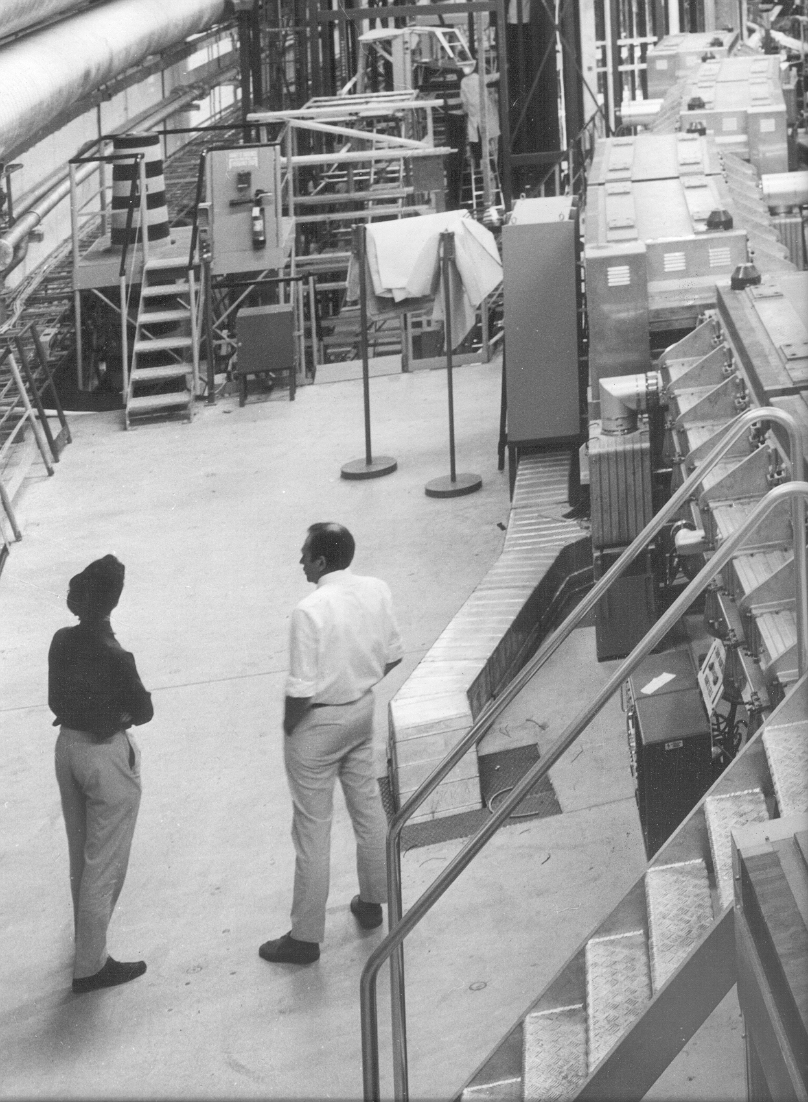

Intersection region 2 of the CERN ISR, July 1971, shortly after first collisions.

